 | International Journal of Advanced Research and Review  www.ijarr.in

GONIEOMETRIC STUDY OF CARRYING ANGLE AND ITS CORRELATION WITH VARIOUS PARAMETERS IN WESTERN RAJASTHAN POPULATION

Raichandani Leena¹, Sharma Karishma^{*2}, Kataria.K. Sushma³, Agarwal Ritu4, Joya Hemkawar⁵ , Raichandani Surbhi⁶

¹Professor, Department of Anatomy, Dr S.N.Medical College,Jodhpur,India
^{*2}P.G.student,Department of Anatomy, Dr S.N.Medical College,Jodhpur,India
³Professor and Head, Department of Anatomy, Dr S.N.Medical College,Jodhpur,India
⁴Assistant Professor, Department of Anatomy, Dr S.N.Medical College,Jodhpur,India
⁵Senior Demonstrator, Department of Anatomy ,Dr S.N.Medical College Jodhpur,India
⁶MBBS student, Dr S.N.Medical College,Jodhpur,India
*Corresponding author email:karishma.ssharma4249@gmail.com
Address:b/32 shiv colony beawar dist- ajmer (raj)
_________________________________________________________________________________________________
ABSTRACT
INTRODUCTION
The angle formed by the axes of the arm and the axes of forearm when the elbow is fully extended and forearm is supinated that obtuse angle is know as “carrying angle”. Carrying angle evaluation is important to identify deformities of elbow. The present study aimed measure and correlation of carrying angle with various parameters in young males and females.
MATERIAL AND METHOD
The present study includes 200 (100 females & 100 males) healthy students of MBBS from Dr S.N.Medical College, Jodhpur, were selected and age groups is 18-22years.Universal Goniometer is used for measurement of carrying angle. Bicipital groove ,biceps brachii tendon at its insertion and palmaris longus tendon at the wrist were palpated and marked as anatomical landmarks to demarcate the median axes of arm and forearm respectively. Measurements were documented and statistically analyzed.
RESULT
The mean carrying angle of male on right limb was 11.80±4.98 and the females was 13.42±6.01,p value (˂0.003) and the mean carrying angle of male on the Left limb was 11.11±5.08 and the female was 13.01±5.97, p value(˂0.01).We observed the greater carrying angle in dominant limb than the non-dominant limb and mean carrying angle was greater in females than males.
CONCLUSION
The present study showed that the carrying angle was greater in females than in males and was greater in dominant arm than in non-dominant arm.
_________________________________________________________________________________
Keywords: Carrying angle,dominant limb, forearm,non-dominat limb,supination

INTRODUCTION
The carrying angle of the elbow is between as the angle formed by the long axis of the armand the long axis of the forearm in the frontal plane when the elbow is fully extended and the forearm is supinated. (¹)
In such a position ,the forearm does not lie in one line with the arm,but it deviates laterl to the armaxis forming this angle.(¹).It is gerally said that the carrying angle is greater in females than the males and the difference has been considered to be a secondary sex characteristics.
The angle is formed as a result of trochlear groove being verticle anteriorly but on the posterior aspect it runs it runs obliquely distally & laterally.This results in formation of carrying angle in extension when posterior aspect of the oblique groove makes contact with the trochlear notch of ulna & the angle is marked during flexion when trochlear notch lies on the vertical groove in the anterior aspect. According to Mall(¹ )the axis of the elbow joint is set obliquely at nearly 84° of both the humerus & ulna which is also agreed upon by Jones(².).Langer(³ )was of the opinion that the obliquity of trochlea to the shaft of the humerus is the cause.
Kapandji(⁴ )explained that the angle is formed as a result of trochlear groove being vertical anteriorly but on the posterior aspect it runs obliquely distally & laterally. This results in formation of carrying angle in extension when posterior aspect of the oblique groove makes contact with the trochlear notch of ulna & the angle is marked during flexion when trochlear notch lies on the vertical groove in the anterior aspect. Ulna a curved ridge joins the prominence of the coronoid & olecranon process which fits the groove in the trochlea of the humerus.
The obliquity of the shaft of ulna to this ridge accounts for most of the carrying angle at elbow. The inner lip of trochlea of humerus is a ridge (groove) which is much deeper distally anteriorly so that ulna (with the forearm) is deflected in full extension by this ridge.
The angle is formed by the medial edge of trochlea of humerus partly projects nearly 6 mm below the lateral edge & the oblique superior articular surface of the coronoid process which is not set at right angle to the shaft of ulna. Some studies showed that the inner lip of trochlea of humerus is a ridge groove deeper in distally anteriorly so ulna is deflected in full extension by this ridge (^{4,5}).
However, some researchers reported no significant difference in carrying angle of males and females of any age.Studies have shown that there is a gradual increase in the carrying angle with skeletal maturation. The apparent difference in gender may be due to increased joint laxity in females permitting a greater degree of extension(⁸)The carrying angle apparently develops in response to pronation of the forearm and keeps the swinging upper extremity away from the side of the pelvis during walking( ⁹ )
The evaluation of carrying angle value and its pathologic variations are important to identify the elbow deformities and in the diagnosis of diseases of the lateral and medial epicondyles.(^{10.11})
The rate of carrying angle increment for boys and girls is 0.42 and 0.60 per year, respectively. Increasing the carrying angle may lead to elbow instability and pain during exercise or in throwing activities of sports , may reduce function of elbow flexion , predispose to risk of elbow dislocation , and increase evidence of elbow fracture when falling on the outstretched hand and fracture of the distal humeral epiphysis .

An increase in the carrying angle is abnormal, particularly if it occurs unilaterally. If the angle is increased beyond the average, it is called cubitus valgus.[^{10,11}] The knowledge of carrying angle is highly significant in the management of various types of fractures of the elbow.[¹⁰]
Women on average have smaller shoulders and wider hips than men, which may be one reason for more acute carrying angle.The olecranon- coronoid angle shows high sexual dimorphism and it may be one of the causes of sexual difference observed in carrying angle[⁴] the importance of evaluating the carrying angle is for handling and monitoring of traumatic lesions that affect the pediatric elbow.
It has been hypothesized that the difference between the carrying angles of the right and left sides may suggest ligamentous laxity at the medial elbow or asymmetrical bone growth.
The knowledge of carrying angle variation in dominant and non-dominant limb is important for reduction of fractures complication of supracondylar fracture and may result in cosmetic deformity and for designing total elbow prosthesis .
Hence, the present study aimed to study the difference in carrying angle between both sexes (Male & female) and to find out any correlation of carrying angle with different parameter like dominant and non-dominant arm as this helps orthopedic surgeon for correction of cubitus varus deformity occurring after malunited supracondylar fracture of humerus

MATERIAL AND METHODS
The present study were carried out on 200 healthy adults.The subjects aged between 18-22 year in the Department of Anatomy,Dr. S.N. Medical College, Jodhpur (Rajasthan) .
Exclusion criteria:The students who have previous elbow injuries as well as congenital anomalies about the elbow will be excluded from the study.
The subjects chosen for the study are evaluated and confirmed for the following data:
1.They are resident of Rajasthan.
2.They have authentic documentation of their date of birth (i.e.birth certificate,driving license,hospital records etc.)
Measurements were taken by Universal Goniometer. It has a body and two thin extension called arms a stationary arm, and a moving arm. It can be either a half-circle instrument with 0° to 180° and from 180° to 0° or full circle Goniometer 0° to 360°and from 360° to 0°. We used Goniometer full circle with a reading from 0' to 360°. The stationary arm is often aligned parallel to the longitudinal axis of the proximal segment of the joint and the moving arm is aligned parallel to the dis segment of joint. Bicipital groove, biceps brachii tendon at its insertion and palmaris longus tendon at the wrist were palpated and marked as anatomical landmarks to demarcate the median axes of arm and forearm respectively. To measure the carrying angle from both upper limbs of right and left side. The fixed arm was placed on the median axis of the upper arm, the movable arm was adjusted as to lie on the median axis and the angle read on the goniometer.

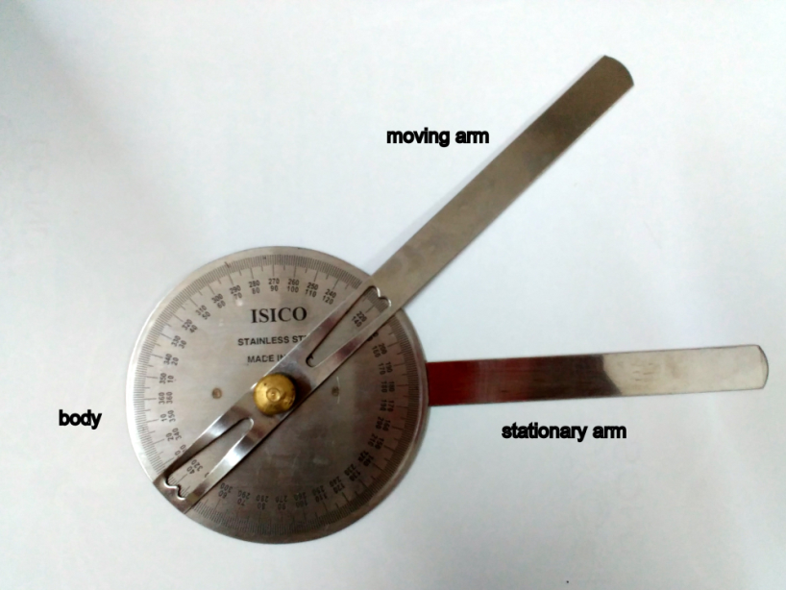
Fig 1: Universal goniometer
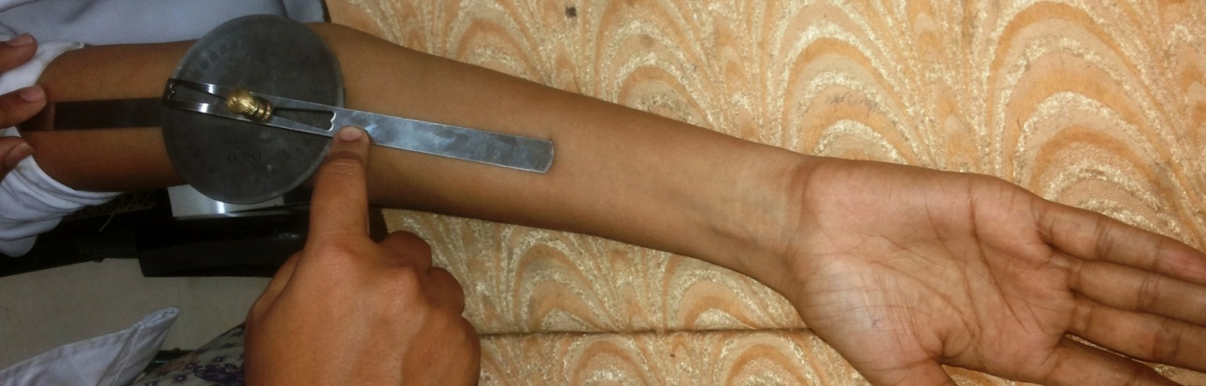
Fig 2: Measuring Carrying angle
DISCUSSION
Apes and humans are distinguished from other primate species in possessing carrying angle at the elbow. The evolution of a carrying angle in apes is related to the need to bring the center of mass of the body beneath the supporting hand during suspensory locomotion as seen in lower limbs of humans in which the valgus knee brings the foot nearer the center of mass of the body during the single limb support phase of walking . The carrying angle permits the arm to be swung without contacting the hips. Women on average have smaller shoulders and wider hips than men, which may necessitate a more acute carrying angle (i.e., less angle than that in male when measured from outside). There is, however, extensive overlap in the carrying angle between individual men and women, and a sex-bias has not been consistently observed in scientific studies. This could however be attributed to the very small sample sizes in those cited earlier studies. A more recent study based on a sample size of 200 individuals from both sexes concluded that carrying angle is a suitable secondary sexual characteristic
Knowledge of the measurement of the elbow carrying angle and of its variations is important when evaluating traumatic elbow injuries in childhood and in adolescence and other elbow disorders that require reconstruction or arthroplasties. Several authors have attempted to determine the variation of carrying angle with age and sex. Potter was the first to carry out an investigation on variation of carrying angle in male and female.He observed the greater carrying angle in females than in males. Subsequent measurements were made by Mall[¹] Since, then different measurements of carrying angle have been performed in a variety of ways ranging from use of a simple goniometer to some complex radiological procedure
A study of Carrying angle and its value in relation to the age has been carried out by many workers. Most other studies have focused on the question of carrying angle difference in sex. Potter(¹⁹), Atkinson & Elftman(²⁰) and R Purkait & H Chardra(²¹) started that the carrying angle is greater in females than inmales & this difference has been considered to be a secondary sex characteristics. The present study deals with the observation on carrying angle and its correlation with height and length of forearm
Shows comparison of average carrying angle in male and female by workers and present study
Study by | Carrying  angle –Male | Carrying  angle –female
Potter8 | 6.83° | 12.65°
Baughman et al9 | 11.0° | 15.0°
J Rai et al10 | 13.26° | 17.91°
Keats et al11 | 11.0° | 13.0°
G. N. Khare12 | 13.56° | 16.92º
Present study | 11.80º | 13.42º

Table‐1 shows values in range, mean and standard deviation of the carrying angle. The average carrying angle of male is 11.80±4.98° on right side,11.11±5.08º on left side and of female is 13.42±6.01° on right side ,13.01±5.97º on left side in present study. Results obtained in present study are quiet comparable with results of other workers study. Results obtained by Potter(¹⁹) and present study are almost similar. From the above study we have observed that the carrying angle in female is greater than male
In the present study it is observed that carrying angle of females(13.42±6.01 right side,13.01±5.97 left side of the arm) is greater than males(11.80±4.98 right side,11.11±5.08 left side of the arm) our study was in line with studies like Khare GN et al (¹²) showed that carrying angle was more in females and they concluded that the carrying angle help in keeping the forearm away from the side of pelvis during walking, the forearm is pronated and carrying angle disappears in pronation of forearm.
Fick (¹³) claimed that the external deviation of the forearm is because of two powerful muscles brachioradialis and extensor carpi radialis longus. These muscles as they located at the radial side abduct the forearm radially and contribute to the formation of the carrying angle. This ‘‘muscular theory’’ explains carrying angle fact that (a) in individuals of athletic and obese constitution, the angle is more as the muscles are well developed, and (b) in older individuals the angle is more as muscles are stronger.
But, in many cases, the muscular theory cannot explained like the carrying angle is more obvious in women, in whom the muscles are less developed than in men. This may be inferior one-third of the shaft of the female humerus appears to have a slight radial deviation, which causes a more carrying angle in women (¹⁴). Aebi et al, Paraskevas G et al. (^{15,16}) concluded that the brachial angle is similar in both sexes, but the ulnar angle of the elbow joint is smaller in women than in men, which causes a more carrying angle in women. Hubscher (¹⁴) noted that the angle is very similar in boys and in men, but varies in females with age, he explained that the hormonal factor may influence the carrying angle in women. Emami et al & Tukenmez et al (^{17,18}) found that carrying angle increases with age because of skeletal maturation and it is always greater on dominant side.
Hence, Most of the studies have focused on cause of formation of carrying angle, difference in sex and age but little attention has given to correlate the carrying angle with various parameters.
Olecranon‐coronoid angle exhibiting high sexual dimorphism may be one of the causes of sexual dimorphism observed in carrying angle. Distal part of the humerus particularly trochlea & proximal part of the ulna play major role in the causation of carrying angle. The study of carrying angle has much clinical significance like extent of the carrying angle is used to determines the type of fracture that a child suffers when falling on an outstretched hand and also cubitus varus deformity can be prevented. The increased carrying angle may also leads to ulnar neuropathy.
First, is it increase angulation of the ulnar nerve pathway and increase the tension & chronic stretching injury of the ulnar nerve at the elbow. Second, the ulnar nerve is angulates two heads of the flexor carpi ulnaris muscle by forward movement of the ulnar nerve resulting from forward movement of the medial head of the triceps brachii muscle in patients with cubitus valgus or cubitus varus deformity . Carrying angle helps in keeping the forearm away from the side of the pelvis when the upper limb swing during walking is also wrong.
The carrying angle is only formed when the forearm is fully supinated & extended at elbow. It disappears in pronation or flexion at elbow. Therefore if the carrying angle is not present & does not help in any way in keeping the forearm away from the side of the pelvis during walking. Present study has no data to compare the obtained results. It may be considered as secondary sex characteristics in female because according to the study of some workers there is no difference in the carrying angle in male & female up to the puberty. But in the female, it is increased after puberty.

RESULT

For this Cross sectional study, 200 students (100 male 100 female) was conducted at medical college, Jodhpur. Out of them 100 students were female & 100 students were male.

Table 1: In Mean differance between males and females. females have greater mean value than the males and the mean carrying angle of dominant hand is greater in both the sexes

Male |  | Female
Carrying angle(degree) |  | Carrying angle(degree) | p value | t value
 | Mean | Mean | p value | t value
Right | 11.80±4.98 | 13.42±6.01 | ˂0.003 | 2.07
Left | 11.11±5.08 | 13.01±5.97 | ˂0.01 | 2.4

GRAPH :1 Showing the Gender wise distribution of age group 18-22 years

GRAPH 2: Correlation between male and female carrying angle

CONCLUSION
The knowledge of variations in carrying angle is essential, especially for the handling and monitoring of traumatic lesions that affect the pediatric elbow .In physiological conditions this parameter varies according to age , gender , hyperextension of the elbow ,dominant upper limb , anthropometric characteristics such as height and intertrochanteric distance and can be measured by simple clinical andradiographic technique
Indera R.Singh and M.K.basin in their study have evaluated the importance of carrying angle in anthropometry which is well accepted,for evaluating traumatic elbow injuries in adolescence and other elbow disorders that require reconstruction or anthroplasties
According to present study there is significant difference between male & female carrying angle, in female it is 13.42 degree on right side 13.01degree on left side and in male it is 11.80 degree on right side and 11.11 degree on left side. Greater carrying angle in female is considered as secondary sex characteristic.
In the results of present study it is consistent with the literature that carrying angle is greater in females because Olecranon‐coronoid angle exhibiting high sexual dimorphism may be one of the causes of sexual dimorphism observed in carrying angle and it may be considered as secondary sex characteristic in female. The highest value of this angle in the female gender would be justified by the presence of ligamentous laxity also. The result of the present study shows the carrying angle is greater in female than in male and it increases at the time of puberty. The carrying angle is greater in dominant arm than in non dominant arm.
This study is an approach to evaluate the carrying angle in vivo for orthopedic application and the recorded measurements might be helpful in management of disorders of the elbow and its reconstruction after fractures. It is of immense help to the orthopedic surgeon for correction of cubitus varus deformity occurring after malunited supracondylor fracture of the humerus and in pediatric elbow surgery. This knowledge is also helpful in dealing with traumatic elbow injuries in childhood and adolescence and other elbow disorders that require reconstruction or arthroplasties.
REFERENCES
1. Mall FP. On the angle of the elbow. Am Anatomy 1905;4:391‐404.
2. Jones FW. 1953 Bachanan’s manual of Anatomy London : Bailliere Tindall and cox Ltd.
3. Langer. On the angle of the elbow. Am J Ant 1905;4:391–404
4. Kapandji I A 1970 The Physiology of Joints
5. Last RJ 1978 Anatomy – regional and applied 6th edn London. Churchill Livingstone Longman.
6. Decker Gog 1986 Lee Mce Gregor’s synopsis of Surgical Anatomy 12th Edn. Bristol : John Wright and Sons Ltd.
7. Williams A, Standring S, Ellis H, Haely J 2005 Gray’s Anatomy.
8. Vichard Lim , Natasha Ashley Jacob (2014):the carrying angle of elbow, An Anthropometric Study on the Carrying Angle of Elbow among Young Adults of Various Ethinicities in Malaysia, NJIRM 2014; Vol. 5(6).November-December pISSN: 2230 – 9969
9. Steel & Tomlinson 1958, pp. 315–7; Van Roy et al. 2005, pp. 1645–56; Zampagni et al. 2008, p. 370
10. Yilmaz E, Karakurt L, Belhan O, Bulut M, Serin E, Avci M. Variation of carrying angle with age, sex, and special reference to side. Orthopedics 2005;28:1360–3.
11. Tukenmez M, Demirel H, Perçin S, Tezeren G. Measurement of the carrying angle of the elbow in 2,000 children at ages six and fourteen years. Acta Orthopaedica et Traumatologica Turcica 2004;38:274–6.
12.Khare Gn, Goel Sc, Saraf Sk, Singh G, Mohanty C, New observations on carrying angle, Indian J Med Sci, 1999, 53(2):61–67.
13. Fick R (1911) Handbuch der Anatomie und Mechanik der Gelenke. Fischer, Jena
14. Hubscher C (1899) Der Ellbogenwinkel. Dtsch Z Chir 53:445
15. Aebi H (1947) Der Ellbogenwinkel, seine Beziehungen zu Geschlecht, Korperbau und Huftbreite. Thesis, University of Basle
16. Paraskevas G, Papadopoulos A, Papaziogas B, Spanidou S, Argiriadou H, Gigis J, Study of the carrying angle of the human elbow joint in full extension: a morphometric analysis, Surg Radiol Anat, 2004, 26(1):19–23.
17. M.j. Emami, f. Abdinejad, s. Khodabkhshi, m. Amini, Andb. Naseri the normal carrying angle of the elbow. In shiraz mjiri, 1998, 12 (1):37-39.
18. Mehmet Tukenmez, Huseyin Demirel, Sitki Percin, Gunduz Tezeren. Measurement of the carrying angle of the elbow in 2,000 children at ages six and fourteen years. Acta orthop Traumatol Turc 2004, 38 (4): 274-276.
19.Potter HP. The obliquity of the arm of the female in extension and the relation of the forearm with the upper arm in flexion. J Anat Lond 1895;29:488‐493.
20.Baughman FA, Higgins JV, Wadsworth TG, Demaray MJ. The carrying angle in sex chromosome anomalies. JAMA 74;230:718
21. Rai J, Parkash S, Singhal V. Carrying angle in Indian girls and boys. Indian journal oforthopaedics 1980;14:170‐174

